**ASSIGNMENT-02**

**DATA VISUALIZATION AND PRE PROCESSING**

|  |  |
| --- | --- |
| **Assignment Date** | 22 September 2022 |
| **Student Name** | Haripriya P |
| **Student Roll Number** | 113219071012 |
| **Maximum Marks** | 2 Marks |

1. Download the dataset: Dataset Dataset downloaded in csv form.
2. Load the dataset.

import pandas as pd rm = pd.read_csv("/content/drive/MyDrive/template/Churn_Modelling.csv")

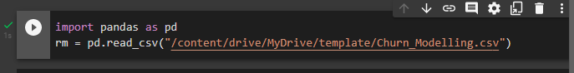

1. Perform Below Visualizations.

* Univariate Analysis

sns.displot(rm['Age'])

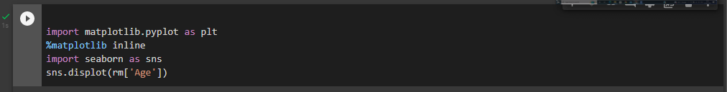

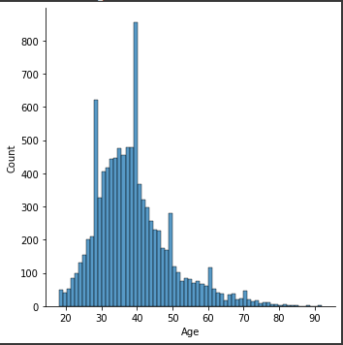

* Bi - Variate Analysis

sns.boxplot(rm['CustomerId'],rm['Gender'])



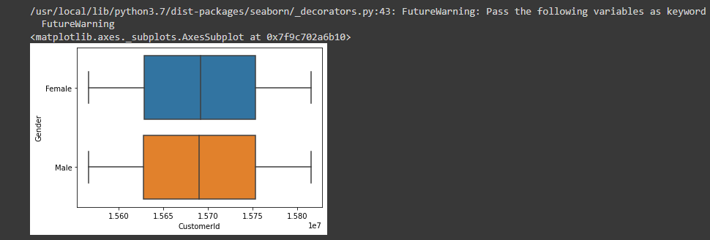

* Multi - Variate Analysis

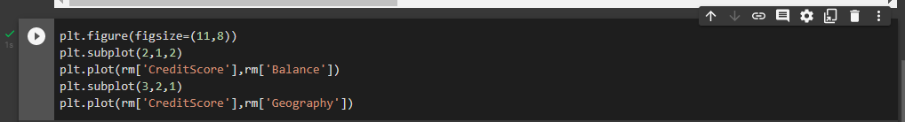

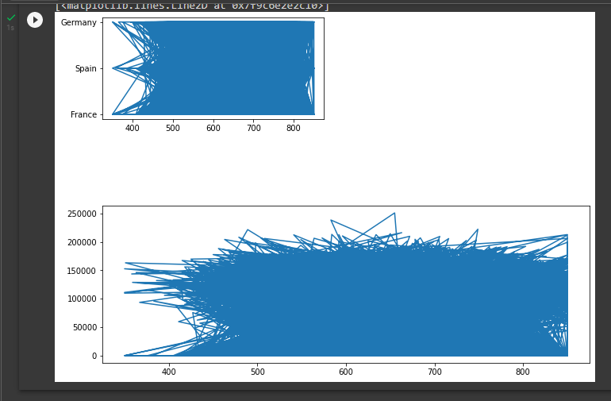

1. Perform descriptive statistics on the dataset.

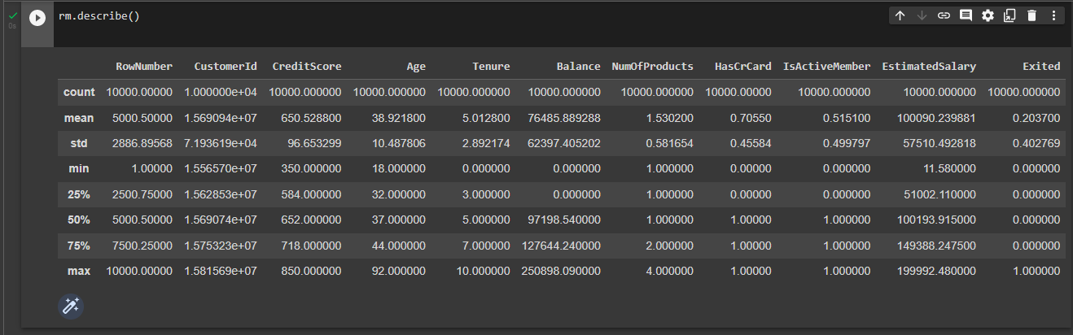

Mean:

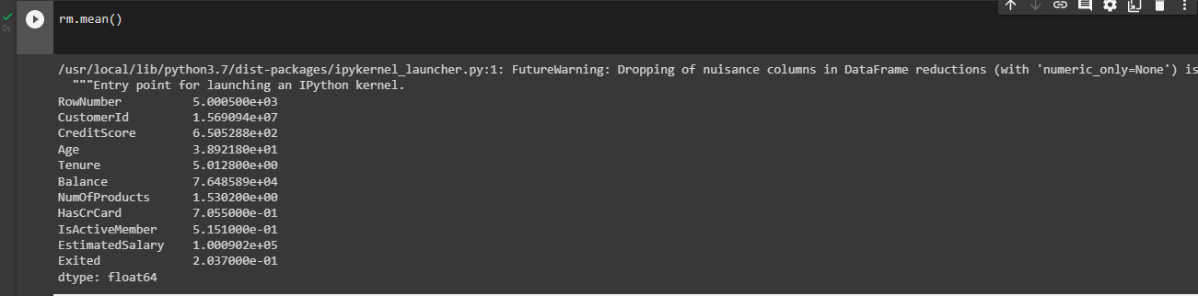

1. Handle the Missing values.

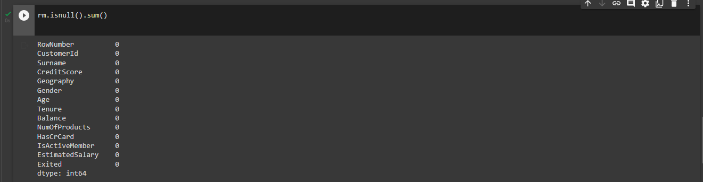

1. Find the outliers and replace the outliers

Finding Outliers:

Using Boxplot

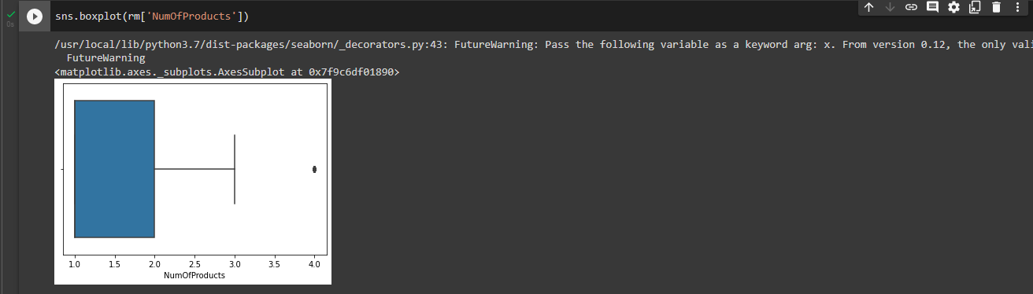

Using method

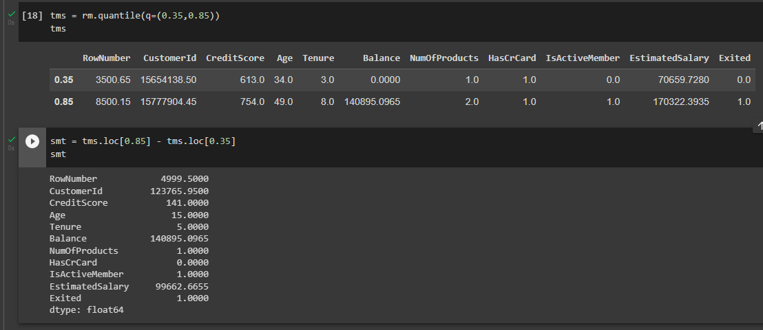



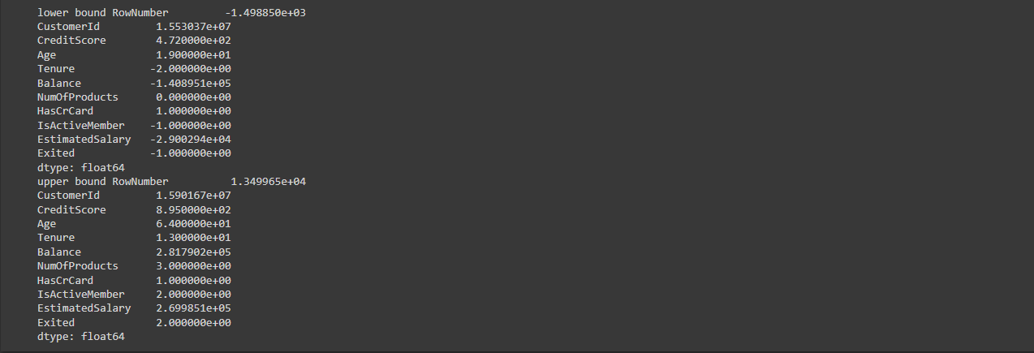

Replacing Outliers:

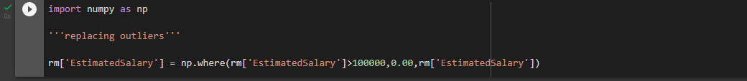

7.Check for Categorical columns and perform encoding.

Categorical columns: Age,Tenure

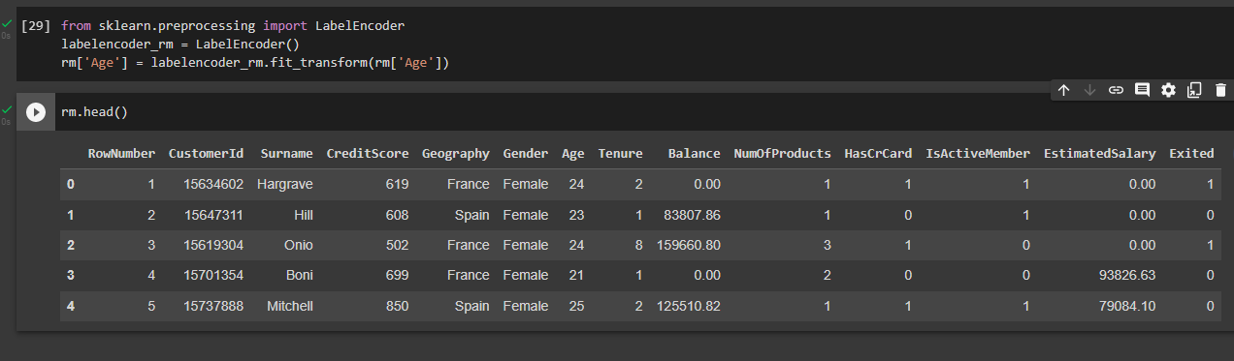

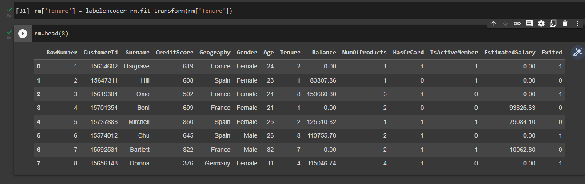

8.Split the data into dependent and independent variables.

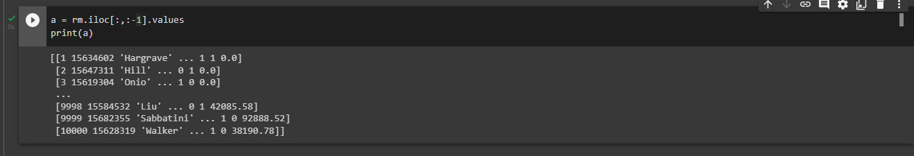



9.Scale the independent variables

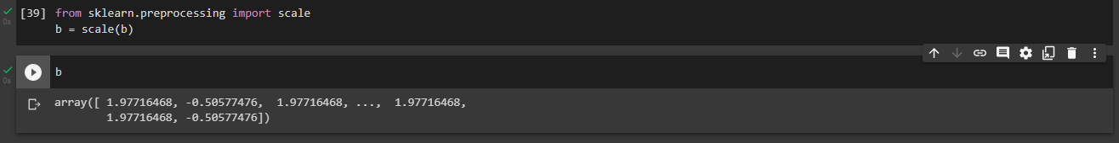

10.Split the data into training and testing

b_train



b_test

a_train

a_test

